*Florida International University*

*School of Computing and Information Sciences*

CIS 4911 - Senior Capstone Project

Software Engineering Focus

Feature Document

User Story # 675

**Team Member:**

Garrett Lemieux

**Product Owner(s)**:

Francisco Ortega

**Mentor(s)**:

Francisco Ortega

**Instructor**: Masoud Sadjadi

**User Story – Implement default Modes**

* As a User I would like to have default modes when certain devices are connected in order to allow for expected functionality with Interactive Paint.
* **Acceptance Criteria**:
  1. Application should have preset modes for different combinations of devices connected to application.
  2. Modes should be automatically set when application starts.

**Use Case**

User wants to have default modes set and running when application begins.

* Details:
* Actor:
  + User
* Pre-conditions:
  + TouchPoint app is running.
  + Devices connected
* Description:
  + Use case begins when User has desired devices plugged in and starts application.
  + User is informed of connected devices and default mode set.
  + Use case ends when user ends application.
* Post-conditions:
  + Appropriate default mode should be set when each combination of devices is connected.
* Decision Support:
  + Frequency: High, Default mode set every time application is ran.
  + Criticality: High, User must have predefined mode when certain devices are connected.
  + Risk: Low
* Usability:
  + Need to know the predefined modes and what the functionality of each mode allows.
  + Needs to know what devices are connected to program when application starts.
* Reliability
  + High
* Performance
  + Performance High
  + Failure Low
* Supportability
  + Multi-Touch Screen (ACER)
  + Leap Motion Device
  + EyeX
* Modification History:
  + Owner: Garrett Lemieux
  + Initiation Date 03/31/2016
  + Date last Modified: 04/03/2016

**Use Case Diagram**

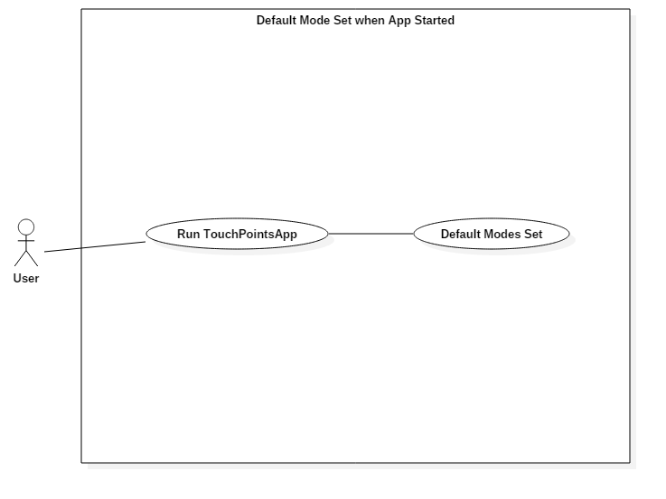

**Sequence Diagram**

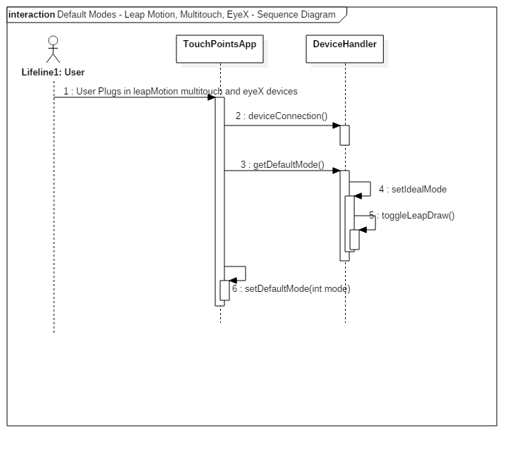

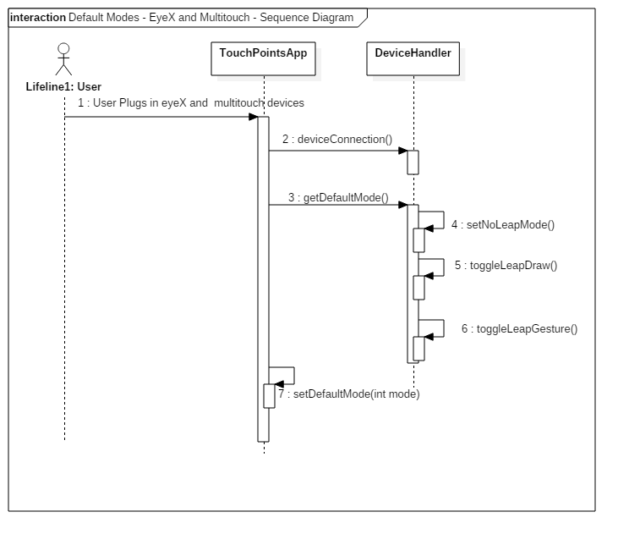

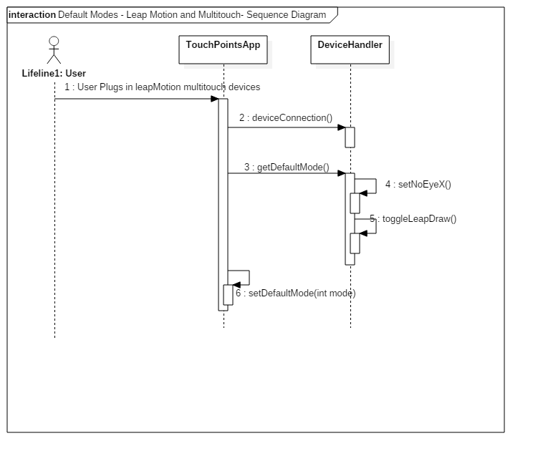

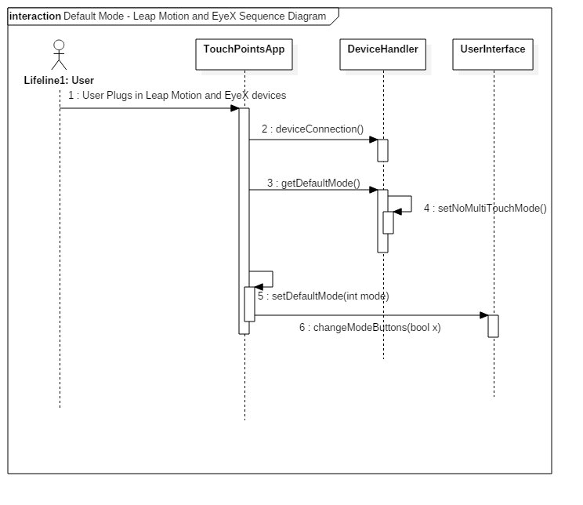

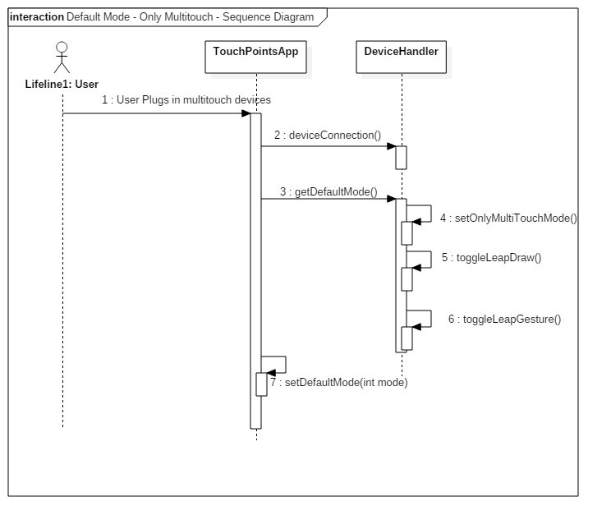

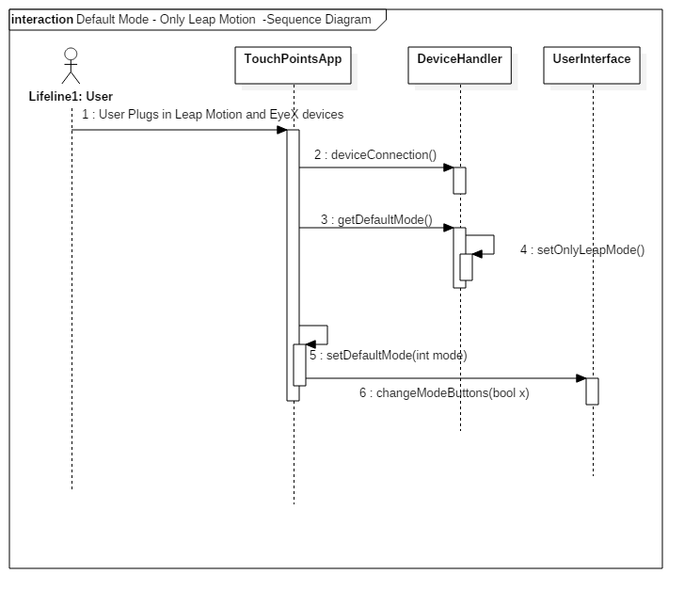

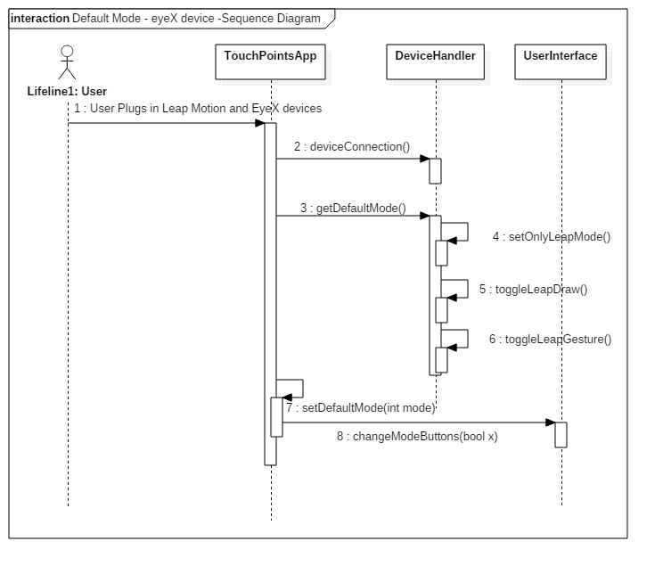

Cl**ass Diagram**

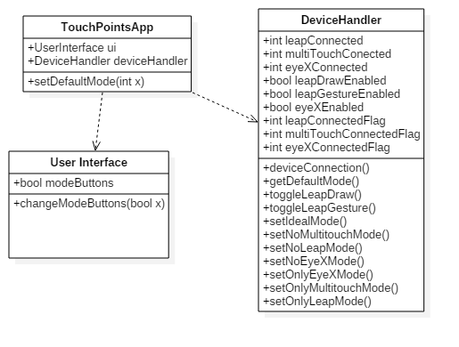

**Unit Test**

* Sunny Day Test:
  + Test Case  - MultiTouch, Leap Motion, and EyeX Connected
    - Test Purpose: To determine if the correct mode is set when these three devices are connected at the start of the application.
    - Test Procedure: User plugs in the multitouch screen the leap motion and eyeX and starts the application. User performs leap gestures and tries to turn on UI menu with eyes. User draws with multitouch screen and presses all buttons.
    - Expected Results: Leap gestures should be read by leap motion. User should be able to draw with multitouch screen and buttons displayed in upper left hand corner. Both radial menu and proximity menu should be functioning. UI menu only show if user uses eyeX and looks in specified location.
  + Test Case  - MultiTouch and Leap Motion connected
    - Test Purpose: To determine if the correct mode is set when leap motion and multitouch devices are connected at the start of the application.
    - Test Procedure: User plugs in the multitouch screen the leap motion and starts the application. User performs leap gestures. User draws with multitouch screen and presses all buttons.
    - Expected Results Leap gestures should be read by leap motion. User should be able to draw with multitouch screen and buttons displayed in upper left hand corner. Both radial menu and proximity menu should be functioning.
  + Test Case  - MultiTouch and eyeX connected
    - Test Purpose: To determine if the correct mode is set when eyeX and multitouch devices are connected at the start of the application.
    - Test Procedure: User plugs in the multitouch screen and eyeX starts the application. User turns on UI menu with eyes. User draws with multitouch screen and presses all buttons.
    - Expected Results: User should be able to draw with multitouch screen and buttons displayed in upper left hand corner. Radial menu should be functioning. EyeX should be able to turn on UI with eye gaze in specified region.
  + Test Case  - Leap Motion and eyeX connected
    - Test Purpose: To determine if the correct mode is set when eyeX and leap motion are connected at the start of the application.
    - Test Procedure: User plugs in the leap motion and eyeX starts the application. User turns on UI menu with eyes. User draws with leap motion and performs leap motion gestures.
    - Expected Results: User should be able to draw with leap motion and leap gesture should be read. Buttons in upper left hand corner should not be active. Proximity menu should be active and eyeX should be able to turn on UI with eye gaze in specified region.
  + Test Case  - MultiTouch connected
    - Test Purpose: To determine if the correct mode is set when only multitouch screen is connected at the start of the application.
    - Test Procedure: User plugs in the multitouch screen and starts the application. User draws with multitouch screen and presses all buttons.
    - Expected Results: User should be able to draw with multitouch screen and buttons displayed in upper left hand corner. Radial menu should be functioning.
  + Test Case  - EyeX connected
    - Test Purpose: To determine if the correct mode is set when only eyeX is connected at the start of the application.
    - Test Procedure: User plugs in eyeX and starts the application. User tries to turn UI menu by gazing in specified region.
    - Expected Results: User should see UI when looking in specified region and buttons in left hand corner should not be active.
  + Test Case  - Leap Motion connected
    - Test Purpose: To determine if the correct mode is set when only leap motion is connected at the start of the application.
    - Test Procedure: User plugs in leap motion and starts the application. User tries to draw with leap motion and perform leap gestures. User also tries to use proximity menu.
    - Expected Results: User should be able to draw with leap motion and gesture should be read. Proximity should function as expected. The UI menu should be present and showing at all times and buttons in left hand corner should not be visible or active.
* Rainy Day Test:
  + Test Case  - MultiTouch, Leap Motion, and EyeX Connected User tries to Draw with leap Motion
    - Test Purpose: To determine if the user can draw with leap motion when default mode is set for specified devices.
    - Test Procedure: User plugs in the multitouch screen the leap motion and eyeX and starts the application. User then tries to draw with the leap motion.
    - Expected Results: User should not be able to draw with leap motion since the default mode specifies this when all three devices are connected.
  + Test Case  - MultiTouch and Leap Motion User tries Draw with leap Motion
    - Test Purpose: To determine if the user can draw with leap motion when default mode is set for specified devices.
    - Test Procedure: User plugs in the multitouch screen the leap motion and eyeX and starts the application. User then tries to draw with the leap motion.
    - Expected Results: User should not be able to draw with leap motion since the default mode specifies this when only leap motion and multitouch devices are connected.

**Integration Testing**

* The default modes were successfully set when all combinations of devices connected were tested.
* Each combination of devices was first connected to local machine and then application started. Each time the functionality of the program was checked for specific default mode.
* After integrating default modes into the application all previous functionality was maintained and functioning correctly.

**User Guide**

* The user does not have to do anything special. The default modes will be set depending on the devices connected.
* The user may choose any device he or she wants to work with and by plugging in the devices the application will detect the devices connected and set the default mode.
* The pictures below show what the user should expect to see with the different device plugged in.
* Multitouch , Leap Motion , EyeX

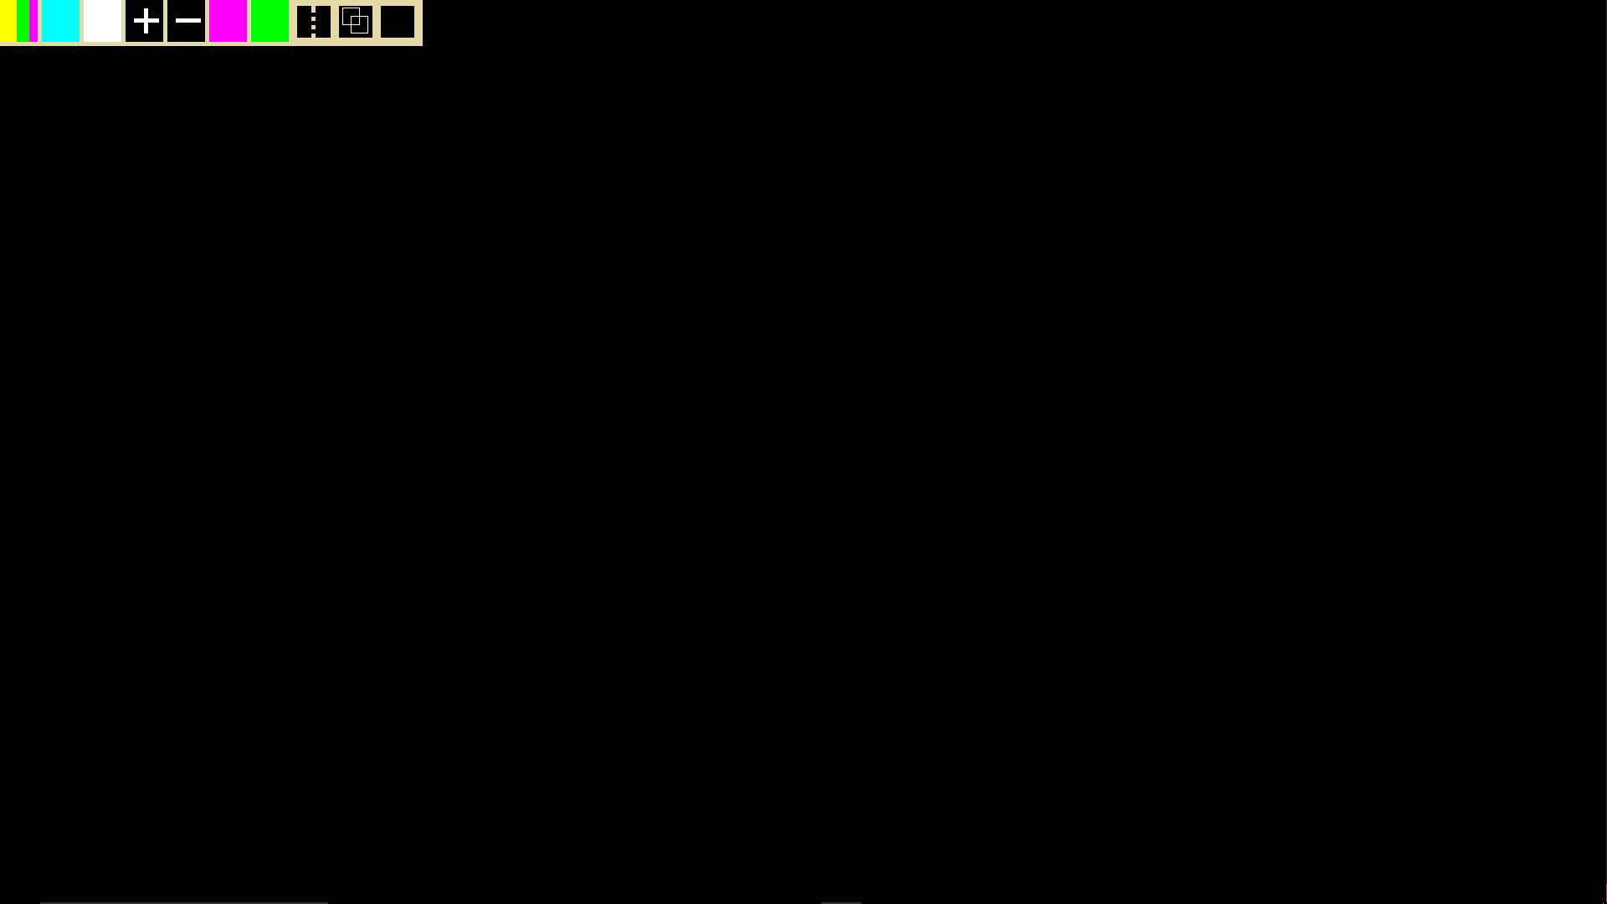

* UI Box in lower right hand corner not shown because eyeX gaze controls the displaying of the UI Box.
* Leap Motion , Multitouch

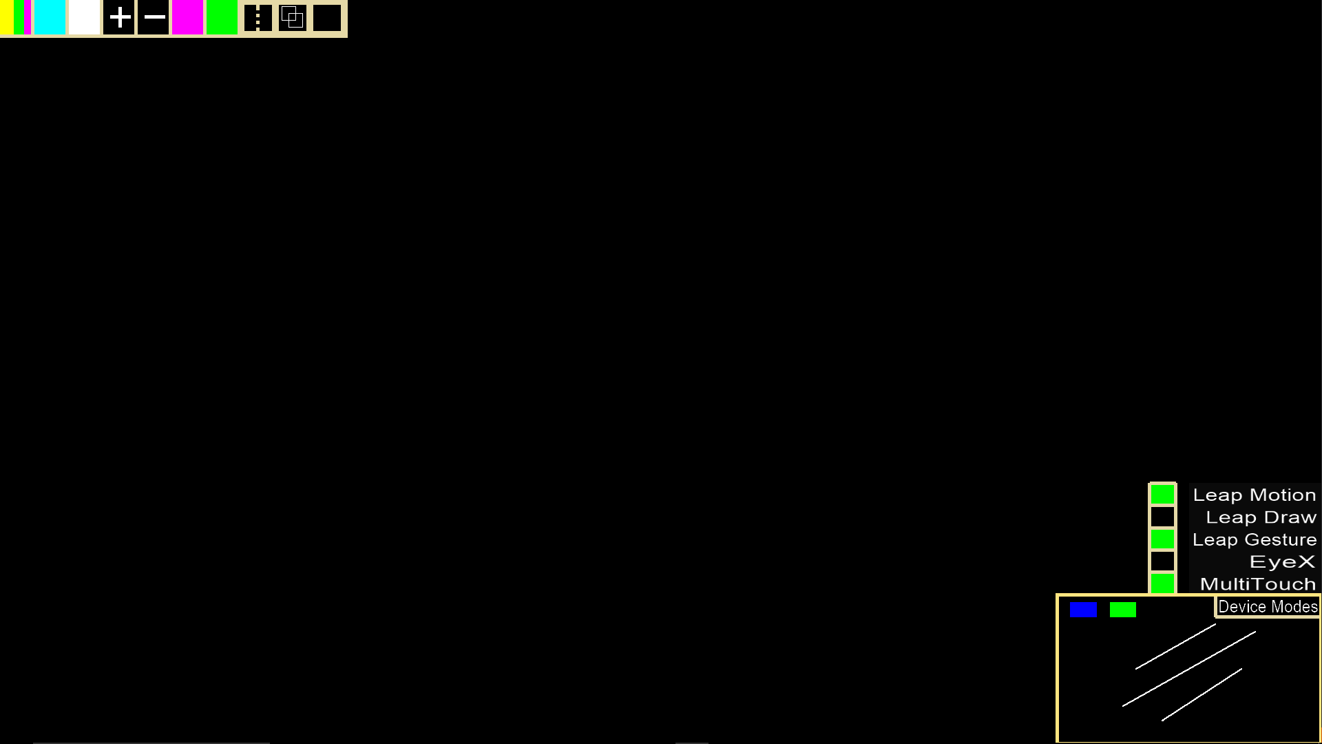

* Leap Motion
* 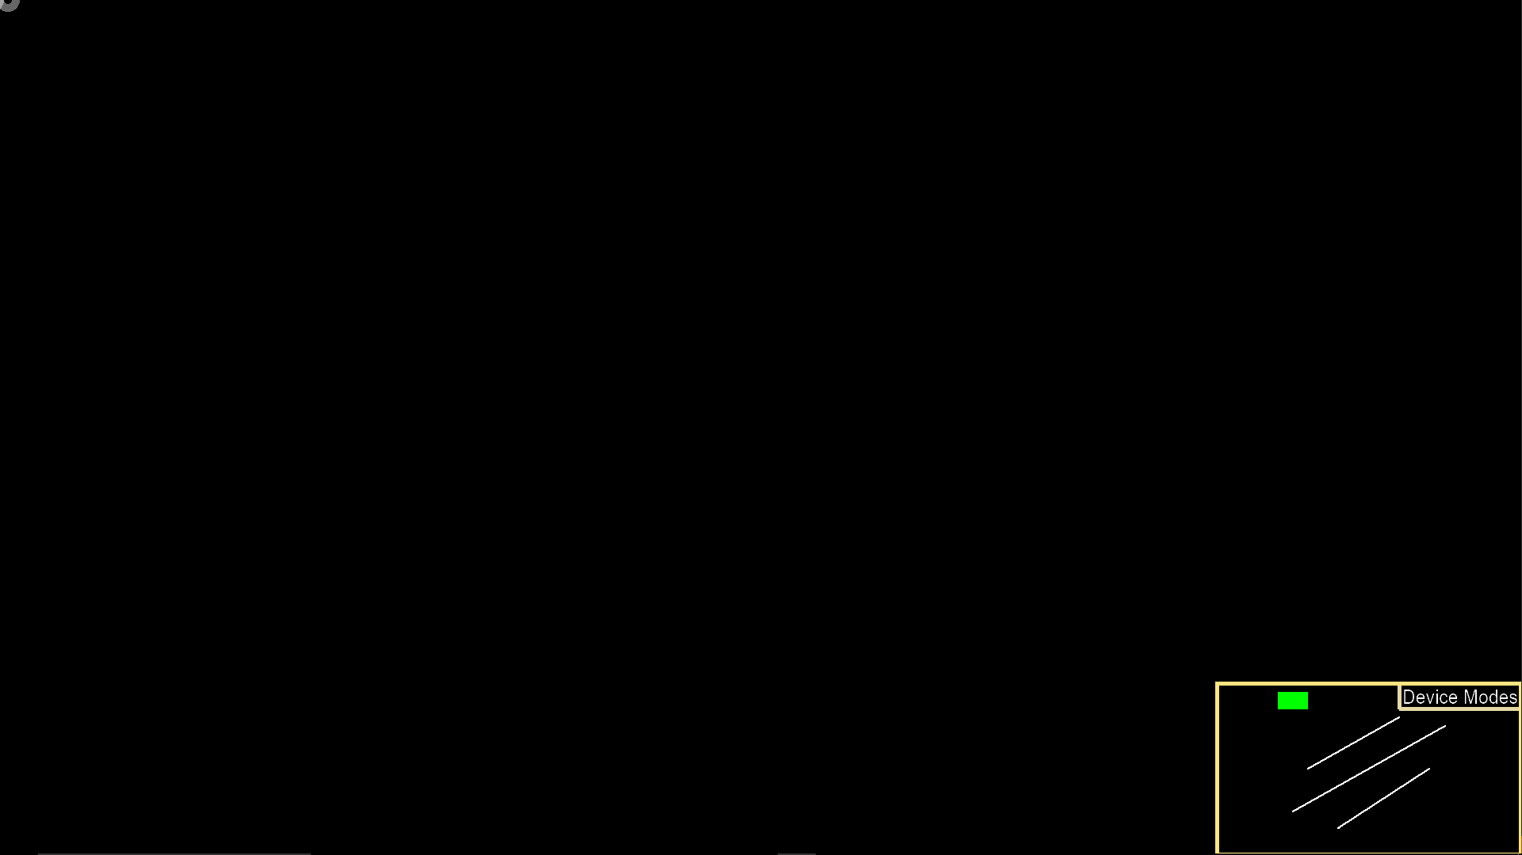
* Buttons in top left hand corner are absent since the multitouch screen is not connected.
* Also the UI box is always on since the eyeX is not connected.

**Glossary**

* **Default Mode -** predetermined settings that are dependent on the devices connected to the application at start time.